Multiplayer Game Development
WRIT1
ST20197697
Patrick Evans

Table of Contents
Introduction 3
Background 3
Report Overview 3
Network Performance Testing 3
Experiment Methodology 3
Test 1 3
Test 2 4
Test 3 5
Result 6
Graphs/Tables 6
Test 1 6
Test 2 7
Test 3 7
Discussion 8
Legal, Ethical, and social issues 8
Legal Issues 8
Ethical Issues 8
Social Issues 8
Conclusion and Future Work 9
References 10

Introduction

Background
This project is to make an SDL2 arcade game based on Asteroids 1979 with the ability to play online with other arcade cabinets in pubs nationwide.

Report Overview
This Report will go over the performance testing that was taken on the game such as increasing the number of players on the screen to how many the game can take before it crashes or how many moving asteroids there can be on the screen before the game crashes, this report will also be discussing the legal, ethical and social issues with having a paid game like this in pubs where people get intoxicated. This report will also discuss how the game can be improved in future development.

Network Performance Testing

Experiment Methodology
These experiments will be increasing the amount of game object in the scene to see how many there can be on the screen at one given time before the game crashes, the game objects that will be increasing are the asteroids and the number of players connected to the game, there will also be a test to see how many bullets can be fired before the game crashes. In test one the independent variable will be the number of players in the scene and the dependent variables will be the number of asteroids in the scene and the number of bullets fired. In test 2 the independent variable will be the number of asteroids in the scene and the dependent variable will be the number of bytes received per second, the number of bytes sent per second and the round-trip time in Ms. In test 3 the independent variable will be the number of bullets fired and the dependent variable will be the number of bytes received per second, the number of bytes sent per second and the round-trip time in Ms. The rationale for these tests is that as the independent variable increases the performance of the game should deteriorate until the game becomes unplayable or crashes on launch, as the independent variable increases so should the number of bytes received per second and the number of bytes sent per second increase as well because there is more loaded into the game at one time. The metrics for these tests will be bytes per second for receiving and sending and milliseconds for the round-trip time.

Test 1
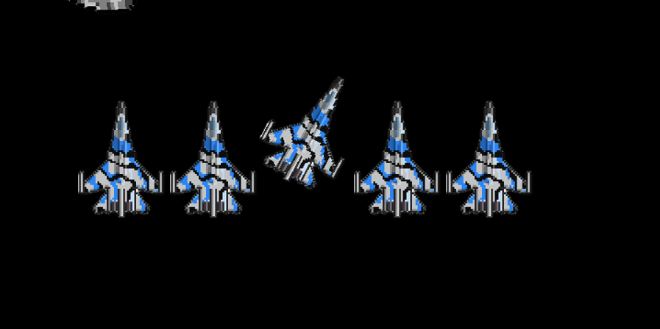
The first test will be carried out to see how many players there can be on the screen at one time before the game crashes, all other aspects of the game will remain the same such as the number of asteroids and the number of asteroid splits.
< Figure 1
In Figure 1 there are 5 players on the same server connection

<Figure 2

In Figure 2 there are 15 players on the same server connection. The PC from which these tests were ran from began to experience some lag and loading issues when booting up a new instance of Visual Studio which would make the game lag whenever a player was moved or joined.

<Figure 3
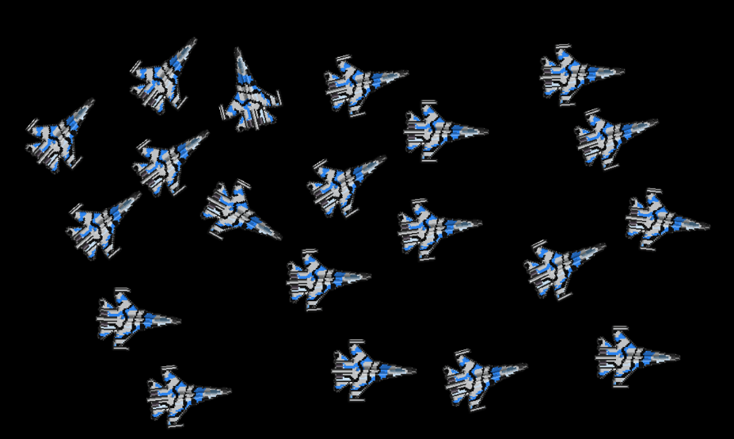
In figure 3 there is 20 players on the same server connection. The PC in which these tests were done on experience more extreme lag and loading issues when loading a new instance of Visual Studio and adding a new player to the game , Due to the lag and loading issues the test had to be stopped at 20 players in one server connection.

Test 2
The second test will test how many asteroids can you loaded into one game at one time before the server crashes. All other aspects of the game will remain default such as the number of players in the game will be 1.
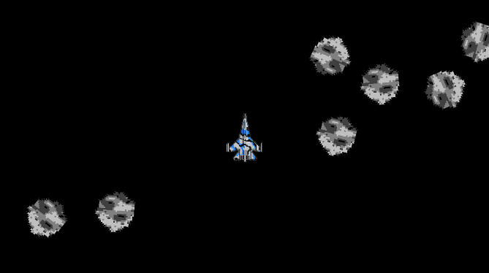
<figure 4
In figure 4 there are 10 asteroids spawned into 1 scene. No lag experienced.


<Figure 5
In figure 5 there are 20 asteroids spawned into 1 scene. A small amount of lag was experienced.

<Figure 6

In figure 6 there is 30 asteroids spawned into 1 scene. A medium amount of lag was experienced.


< Figure 7
In figure 7 there is 34 asteroids spawned into 1 scene. A moderate amount of lag was experienced.

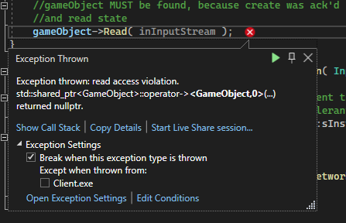
<Figure 8
In figure 8 35 asteroids tried to spawn into 1 scene but the game crashed as it tried to load them all.

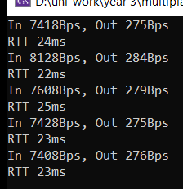
<figure 9
In figure 9 is the number of bytes in and out and the round-trip time every 5 seconds with 10 asteroids on the screen.
Average in: 7598
Average out: 277

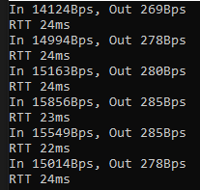
<figure 10
In figure 10 is the number of bytes in and out and the round-trip time every 5 seconds with 20 asteroids on the screen.
Average in: 15137
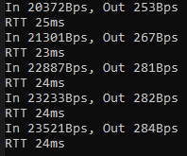
average out: 279
<figure 11
In figure 11 is the number of bytes in and out and the round-trip time every 5 seconds with 30 asteroids on the screen.
Average in:22262
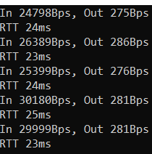
average out:273

<figure 12
In figure 12 is the number of bytes in and out and the round-trip time every 5 seconds with 34 asteroids on the screen.
Average in:27353
Average out: 279

Test 3
This test will see how many bullets can be fired in quick succession before the game crashes. All other elements of the game will remain the default.

<Figure 13

in figure 13 and 14 you can see that after the player shoots 58 bullets the game crashes

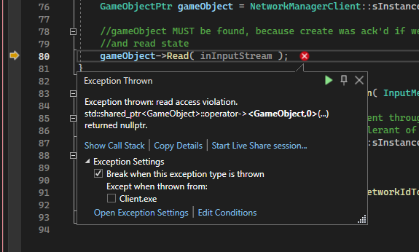

<Figure 14

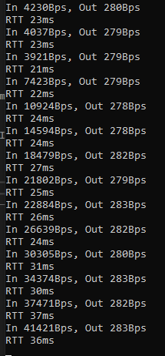
<figure 15
In figure 15 each set of data represents another 5 bullets being fired apart from the bottom set of data which is 58 as the game crashed after that amount.

Result

Graphs/Tables

Test 1

From this graph there is a clear indication at a increase in players to the game increases the amount of lag that is experienced. This is because all the players are sharing a bandwidth and the more players on the bandwidth the less space each player has on it.

Test 2
in test 2 there is evidence that as the number of asteroids increased the amount of lag that was being experienced. Once the number of asteroids hit 35 the game crashed on launch due to the amount of lag

this table shows that as the number of asteroids in the game increased so did the number of bytes received per second.

This table shows that as the number of asteroids increases the number of bytes sent stays roughly the same.

Test 3

In test 3 there is evidence that as the number of bullets fired increased so did the amount of lag and when the 60th bullet was fired the game crashed.

In this table there is a clear comparison of as the number of bullets fired increases so does the number of bytes received per second.

there is no clear comparison to the number of bullets fired and the number of bytes sent per second.

Discussion
One of the reasons why the game crashed in all 3 tests was due to latency issues because the more objects there are in the game the more data is trying to pass from one point to another in the network which causes high latency which can cause the game to jitter or lag until the game crashes. One of the reasons why test 1 crashes is due to the amount of bandwidth required to have so many players in the game at once which made the bandwidth overloaded. In test 2 we see a steady increase in bytes received per increase in asteroids, this is because all of the game objects are sending bytes of data to the game which adds to the bandwidth of the game, this increase in bytes received is also the reason why the game crashes because the game can’t process that amount of bytes due to it not having a large enough bandwidth, the same pattern can be see in test 3 as the number of bytes received increases as the number of bullets fired increases. Another similarity between tests 2 and 3 is that both tests' sent bytes remain roughly the same in the test even when the bytes received have drastically increased. A difference between tests 2 and 3 is that test 3 round trip time is slightly higher than test 2 round trip time.

Legal, Ethical, and social issues

Legal Issues
One of the legal issues with having a paid arcade game in a pub is that the pub needs a licence from the gambling commission to have the arcade in the pub. Another legal issue is that to get the licence the game must have certain odds and payouts, the licence also only lasts 10 years and then the pub would have to pay to get the licence renewed. Another legal issue is that to have a machine in the pub there must be a list displayed by the machine displaying information about the machine such as the category it falls into as well as the % of return, the stake and prize limits and other things (PopplestoneAllen, 2021). Some of the ways to solve these legal issues is to make sure the pub has a licence that they have a sign displayed and that the machine has a set cash prize and stake amount.

Ethical Issues
Some of the ethical issues with having a paid arcade cabinet in a pub are that the game's users will most likely be intoxicated, potentially leading them to pay for more games, which they wouldn’t have done if they were sober. One study on the effects of drinking and gambling found that alcohol consumption was associated with larger bets and more rapid loss of all funds (Jessica M. Cronce, 2010) another study came to a similar conclusion that gambling is higher amongst more frequent drinkers and those who do multiple forms of gambling consume more alcohol on their biggest drinking days (Dr Guy Bohane, 2015). Some of the ways the ethical issues could be solved is by capping the betting amount and not letting intoxicated people use the machine.

Social Issues
Some of the social issues a person could get while using the machine is that they could get addicted to the machine and end up spending more money than they have on it which can lead to bankruptcy. Another social issue is that gambling can lead to low self-esteem, stress, anxiety, and depression (Mental Health Foundation, n.d.). Another study found that university students who drink to cope and have other indications of alcohol problems also gamble to cope (Dr Guy Bohane, 2015). Some of the ways to solve the social issues are to stop people from using the machines after a set amount of time or ban them entirely if they keep losing all their money.

Networking
For multiplayer games, 2 main types of networking can be used TCP and UDP. UDP is useful for fast-paced multiplayer games because the UDP protocol is to sync player movement and updates the game state as fast as possible, some downside of that is that due to the fast speeds, it is possible to lose a message in transit because the next message is so close behind it (Carroll, 2023). UDP is also useful in combating high latency because UDP doesn’t require receiving systems to send acknowledgement which can lead to a reduction in delays when compared to TCP (Kentik, n.d.). network latency is the time delays during data transmission over the network, this causes jittering or lag (Kentik, n.d.).

Conclusion and Future Work

Primary research
In conclusion, many improvements could be made to the game to make it run smoothly such as having a larger bandwidth because when this game cabinet is connected to other cabinets across the country and amount of bytes received per second is going to be a lot higher than the amount seen in the tests this is because there will be more players in the game and due to that there will have to be more asteroids and bullets being fired at the asteroids. Another improvement that can be made in the game is to fix the jittering problem which is caused due to high latency in the game. The game also experienced lag once more than 10 players had joined the game, this resulted in the game lagging when a new player joined and when the new player first moved.

Secondary research
In conclusion, the latency issues that have been experienced in the game can be mitigated by implementing solely UDP to the game which should decrease the waiting time during data transmission. Some future work would be to make sure that any betting and payouts in the game were capped to meet the legal requirements of the game, the game cabinet would also have a mandatory sign on the side of the cabinet informing players of what category the machine falls under and the % returns that the machine has, and the stake and prize limits. Other future work would be to make sure there are safeguarding measures in place in all the pubs which have a cabinet so that players don’t overspend and get into debt.

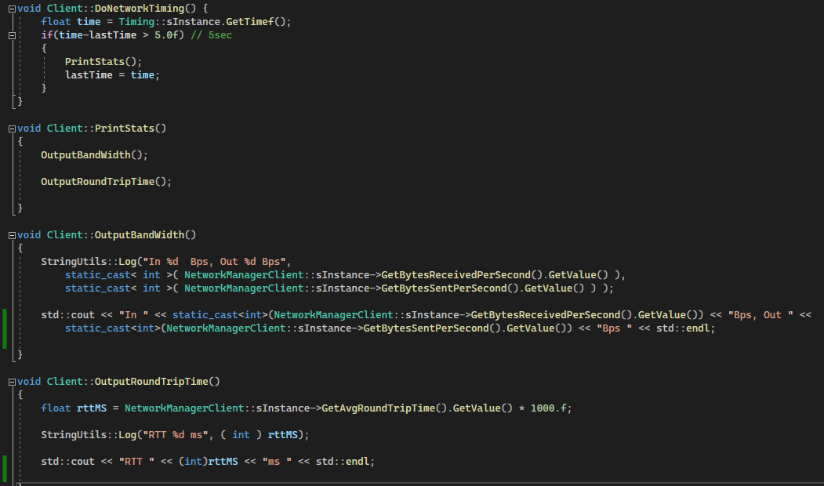
Testing Code

References
Carroll, M. (2023, 02 20). UDP vs TCP: Why to Run Gaming Servers Separate from Chat. Retrieved from PubNub: https://www.pubnub.com/blog/tcp-vs-udp/
Dr Guy Bohane, P. Y. (2015). The Relationship Between Alcohol and Gambling Behaviours. London, United Kingdom.
Jessica M. Cronce, W. C. (2010). Effects of Alcohol and Initial Gambling Outcomes on Within-Session Gambling. Exp Clin Psychopharmacol, 145-157.
Kentik. (n.d.). Network Latency: Understanding the Impact of Latency on Network Performance. Retrieved from Kentik: https://www.kentik.com/kentipedia/network-latency-understanding-impacts-on-network-performance/#:~:text=UDP%20vs.,to%20send%20acknowledgments%2C%20reducing%20delay.
Mental Health Foundation. (n.d.). What causes problem gambling. Retrieved from Mental Health Foundation: https://www.mentalhealth.org.uk/explore-mental-health/a-z-topics/gambling-and-mental-health#:~:text=including%20compulsive%20gambling-,How%20can%20gambling%20affect%20my%20mental%20health%3F,our%20brain%20that%20releases%20dopamine.
PopplestoneAllen. (2021, 07 21). The Rules Surrounding Gaming Machines in Pubs. Retrieved from PopplestoneAllen: https://www.popall.co.uk/news-publications/publications/gaming-machines-in-pubs

